Large Applications Practicum
Group-3
Design Document

Vishnu Priya Jindal (B16041)
Ananya Shukla (B17007)
Aman Saxena (B17034)
Aaditya Arora (B17071)

October 2019
Evoice: The Text-to-Speech Synthesizer
Design Document
Revision History
Version | Date | Author(s) | Description
v1.0 | 10/16/19 | Vishnu Priya Jindal, Aaditya Arora, Aman Saxena, Ananya Shukla | Initial version

Table of Contents
Introduction 2
Design Overview 3
Intended Audience 3
References 3
Detailed Design 3
Architecture 4
Components 4
Interfaces 4
Algorithms and Data Structures 4
External Data 4
Databases 4
Files 5
Performance 5

Introduction
Evoice is an offline GUI-based text-to-speech synthesizer for English and other languages, developed in order to help the visually impaired people using computer generated voice which can read the text to the user.

Design Overview

Evoice is based on Festival TTS which is a C++ library that offers text to speech through several APIs. Evoice has created a Python2 based wrapper that calls the functions from Festival. The GUI is built in Python2 and reads text either from the input field or from a file.

Intended Audience
This document is intended for software designers and students who have an interest in the field of software development. This may also be read by the users of this product.

References
[1] http://espeak.sourceforge.net/
[2] http://www.cstr.ed.ac.uk/projects/festival/
[3] https://en.wikipedia.org/wiki/Speech_synthesis

Detailed Design
The software is written in Python2 and uses the C++ APIs of Festival.

Architecture
The product is built on the Festival TTS that provides C++ APIs to read the text in a computer generated voice. It creates Python wrappers to call the C++ functions provided by Festival TTS.
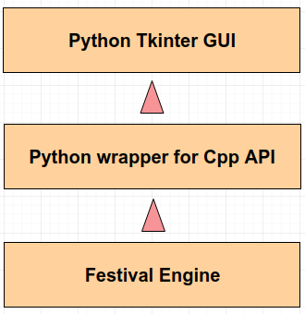

Components
Festival is used as-is, offering APIs for text to speech conversion.
Main.py contains the wrappers in Python2 that are used to call the C++ functions of Festival.
GUI built using Tkinter library that provides the text field for input, slider for the rate and an option to choose a text file.

Functionalities
- We can convert text, from the dialogue box (GUI) as well as from any file in .TXT, . PDF format, to speech.
- We can change the speed of speaking.
- Inter-line and inter-para pause feature is added.
- We can highlight the text, which we want to be read out.
- We can change the accent of speech.

Interfaces
The Backend of the application is written in Python and is using Festival Cpp API. The Frontend of the application is also written in Python and is connected to the backend by importing the functions defined in the backend.

Algorithms and Data Structures
There are no significant algorithms or data structures developed for this product.

External Data

Files
Evoice provides the users with an option to read the text files apart from the manual method.

Performance
The performance of the product can be tested by running files of different sizes.

